# Index.jsp – Main webpage of the application with the search form of flights:

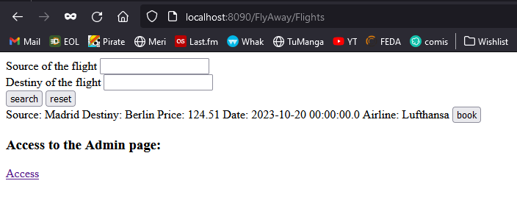

# Purchase – After pushing the book bottom, we access to the details of the flight, and we can add our personal details to book the flight:

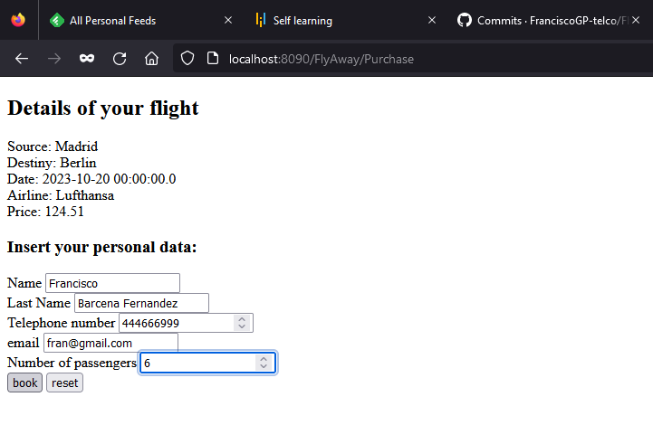

# Confirmation – We check all the details of the flight, the total price, and the personal data of the customers. Now is need to insert the card number:

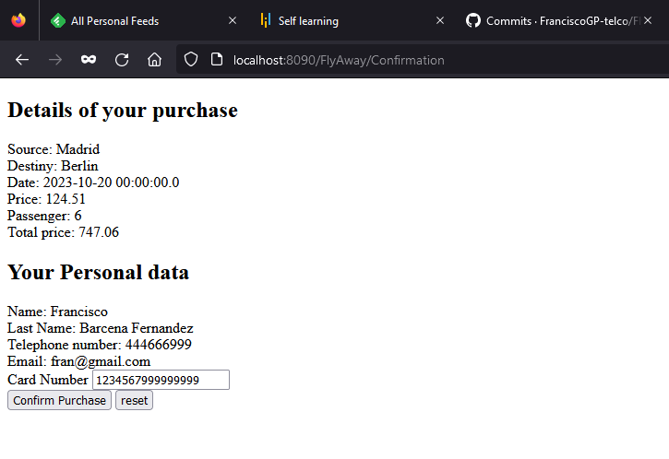

# Finish – We show the confirmation of the operation:

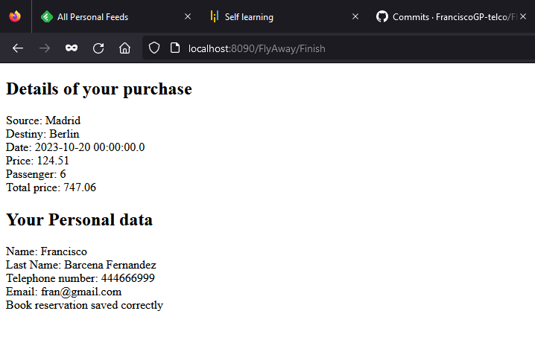

# Checking the DB table:

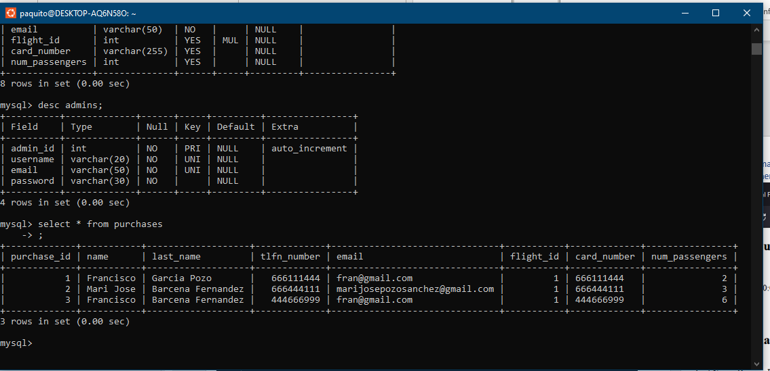

# Login.jsp, to access to the admin webpage:

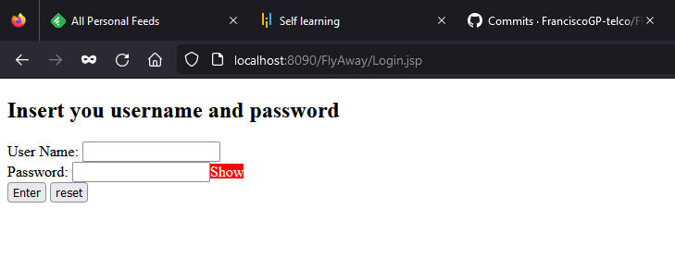

# Admin: After login, we can check all the info of the admin webpage:

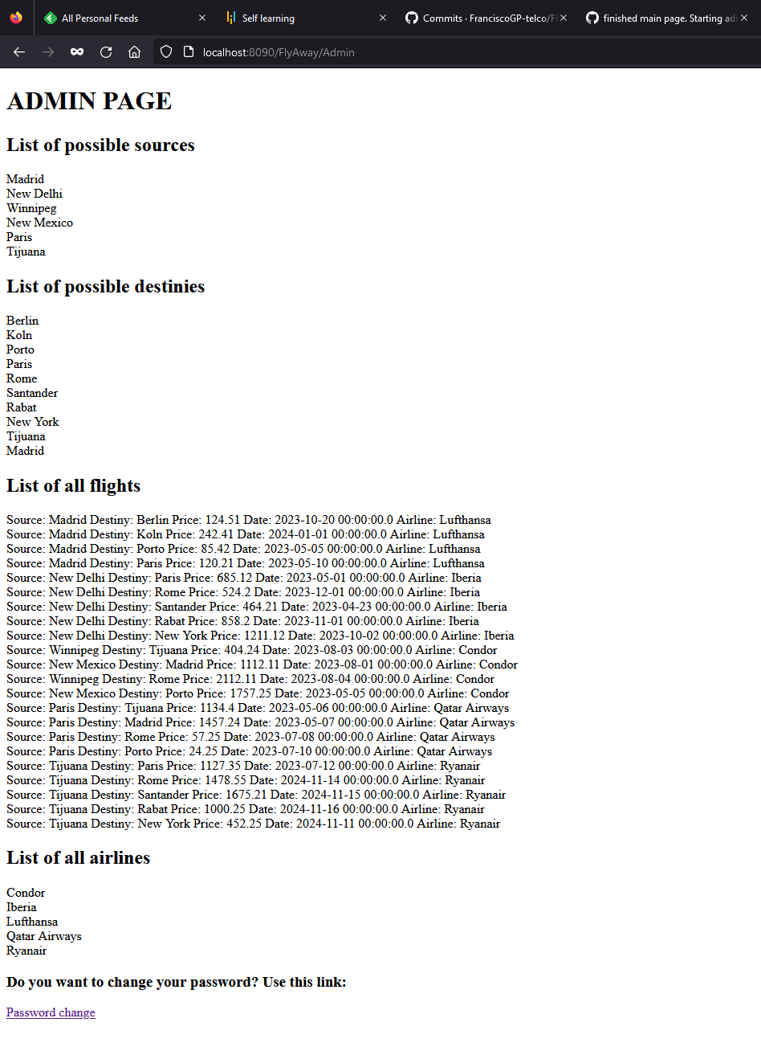

# Password: We can change the admin password of the user authenticated:

# 

# After change the password, we come back to the login webpage:

# 

More info about the project can be found in the GitHub project:

<https://github.com/FranciscoGP-telco/LockedMe.com>